




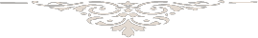

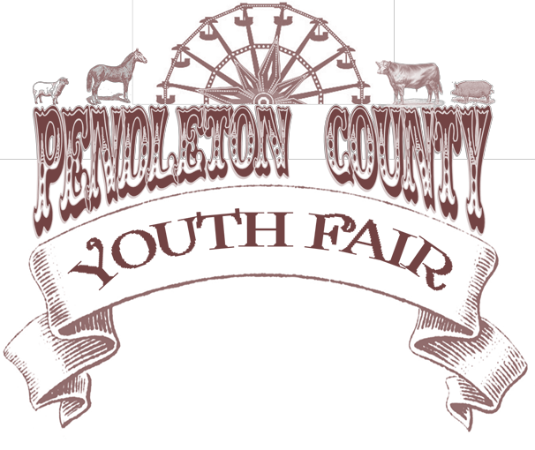
January 21, 2026

Greetings Pendleton County Youth Fair Supporter,
Planning for the Pendleton County Youth Fair is well underway and will take place June 21-27, 2026. The Pendleton County Youth Fair Association is a non-profit corporation and operates exclusively for educational and charitable purposes within the meaning of SecHon 501
(C) (3) of the Internal Revenue code. The Pendleton County Youth Fair Association’s purpose is to promote the development of youth through agriculture, cultural arts, education, industry and business to the general betterment of Pendleton County and its rural heritage through the facilitation of a county fair.
With the generous support of local businesses, the Pendleton County Youth Fair in years past has been able to contribute to the development of youth in our county. The Pendleton County Youth Fair Association is able to accomplish this through various programs in collaboration with student led organizations such as 4-H and the National FFA Organization. It is only through the continued partnership with organizations such as yours, that we are able to succeed in our community development and celebration endeavors.
We are excited to be offering these sponsorship packages to aid you in promoting your business
while supporting a community event that advocates youth development. We have an array of options to meet your needs and would be grateful for your support.
Please review our sponsorship packet and consider joining us in our mission to promote and advocate the development of youth in our county. If your organization would like to participate in this year ’s event, please contact us with your package selection by March 1, 2026.
Thank you for your time and consideration.
Sincerely,

Pendleton County Youth Fair Association

THANK YOU FOR SUPPORTING OUR YOUTH




Contact Person:
 | Last | First
Business Name:
 | (as you would like to appear on display)
Address:
 | Street Address | City | State | Zip
Office Phone: |  | Cell Phone:
Email Address:
- I would like to contribute an item to be used as an In-Kind Donation.
Item and Value:

- I would like to SPONSOR THE PENDLETON COUNTY YOUTH FAIR
WHITE RIBBON SPONSORSHIP PACKAGE $50

 | RED RIBBON SPONSORSHIP PACKAGE | $100
 | BLUE RIBBON SPONSORSHIP PACKAGE | $250
 | RESERVE SPONSORSHIP PACKAGE | $500
 | GRAND SPONSORSHIP PACKAGE | $1,000
 | SUPREME SPONSORSHIP PACKAGE | $2,500 & above

I would like to make a DONATION $
PLEASE SELECT AN AREA WHERE YOU WOULD LIKE YOUR SPONSORSHIP TO BE APPLIED

ENTERTAINMENT

FLORAL HALL

HORSE SHOWS
LIVESTOCK SHOWS
MOTORSPORTS
PAGEANTS
GENERAL FUNDS
If you would like to sponsor a specific class/event, please specify:

Please make checks payable to Pendleton County Youth Fair Association

SPONSORSHIP PACKAGES

WHITE RIBBON SPONSORSHIP PACKAGE  $50 | RED RIBBON SPONSORSHIP PACKAGE  $100 | BLUE RIBBON SPONSORSHIP PACKAGE  $250
- Listing of company name in  the fair catalogue  - Name listed on website sponsor page  - Combined advertising sign on fairgrounds | - Business card size advertisement in fair catalogue  - Name listed on website sponsor page  - Combined advertising sign on fairgrounds | - 1/4 page advertisement in  fair catalogue  - Name listed on website sponsor page  - 18” x 24” advertising sign on fairgrounds at your chosen location
RESERVE SPONSORSHIP PACKAGE  $500 | GRAND SPONSORSHIP PACKAGE  $1,000 | SUPREME SPONSORSHIP PACKAGE  $2,500 & Above
- 1/2 page advertisement in fair catalogue  - Name listed on website sponsor page  - 3’ x 5’ advertising banner on fairgrounds | - 3/4 page advertisement in fair catalogue  - Name listed on website sponsor page  - 3’ x 5’ advertising banner on fairgrounds  - Free Booth Rental to promote your business  - 2 Free Pendleton County  Youth Fair Week Long Passes | - Full page advertisement in fair catalogue  - Name listed on website sponsor page  - 3’ x 5’ advertising banner on fairgrounds  - Free Booth Rental to promote your business  - 4 Free Pendleton County  Youth Fair Week Long Passes  - One night of the 2025 fair named after your business/ organization

